Welcome!
Date
Name
Spouse
Address
City
State Zip _________
Email

Please Contact By
❑ Card  Phone  Visit

Telephone Best Time to Call
Home ______________
Work ______________

Guest: First Time Second Time
Are you a church member: yes no
Church
City, State

Circle Appropriate Age/Grade Group(s)
Preschool: Ages: B-1 2-3 4-5
Children: Grades: K 1 2 3 4 5 6
Youth: Grades: 7 8 9 10 11 12
Adults: Ages:18-29 30s 40s 50s 60s+

How did you learn about our church?
Newspaper Friend Yellow Pages Mail
Other

I am a guest of:

New in the Community? Yes No
Names & ages of children at home

Weekly Service & Activity Schedule
November 10, 2013
9:45 a.m. Sunday School
11:00 a.m. Morning Worship

6:00 p.m. Evening Service / BUISNESS MEETING

Week of November 11 – 16

Wednesday, 6:30 p.m. Youth Activities
Wednesday, 6:45 p.m. Adult Prayer & Bible Study
Wednesday, 7:30 p.m. Praise Team Rehearsal
Thursday, 10:00 a.m. Senior Adult Fellowship
Thursday Independence Assoc Meeting - Caldwell

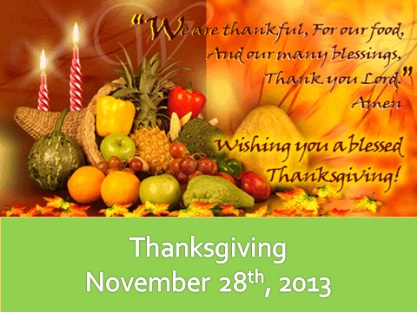



Thanksgiving Meals Baskets
Every year we reach out to families that are in need. If you would like to help in this ministry, the next few weeks we’ll be collecting items. There will be a sign-up sheet at the church. Together we all can spread our love and supply these families with a Thanksgiving meal. Please contact Evelyn Robinson to help!!
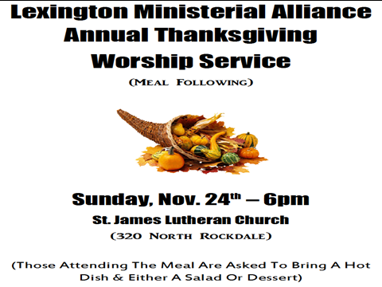
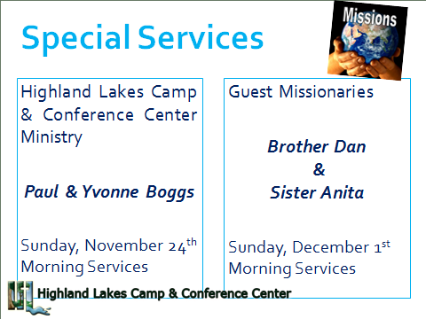
Knobbs Springs Baptist Church

"From the least to the greatest,
all are greedy for gain;
prophets and priests alike, all practice deceit.
They dress the wound of my people as though
it were not serious.
'Peace, peace,' they say, when there is no peace.
Are they ashamed of their loathsome conduct?
No, they have no shame at all;
they do not even know how to blush.
So they will fall among the fallen;
they will be brought down when I punish them,"
says the LORD.
Jeremiah 6:13-19

Woe to those who call evil good and good evil,
who put darkness for light and light for darkness,
who put bitter for sweet and sweet for bitter.
Isaiah 5:20

November 10, 2013

Church Information:
KnobbsSpringsBC.com KnobbsSpringsBaptist@gmail.com
1662 CR 305, McDade, Texas 78650 512-273-2743
Brother Dwight Reagan 512-247-6448
Kimberly Tabor, Office Manager 512-698-2804

